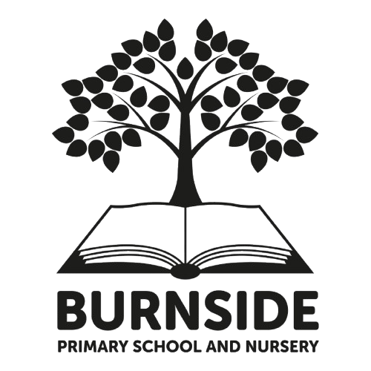

Pupil Acceptable Use Agreement
Key Stage 2

This acceptable use agreement is intended:
- to ensure that learners will have good access to devices and online content, be responsible users and stay safe while using digital technologies for educational, personal and recreational use
- to help learners understand good online behaviours that they can use in school, but also outside school
- to protect school devices and networks from accidental or deliberate misuse that could put the security of the systems and users at risk.

Acceptable Use Agreement

I agree to use the school’s digital systems safely and responsibly to protect me, other learners and the school.

Keeping Safe Online
- The school will check how I use devices and the internet to keep everyone safe.
- I will keep my usernames and passwords private and tell a trusted adult if someone else knows them.
- I will be careful when talking to people online and will only talk to people I know and trust.
- I will not share personal information like my name, address, or photos without asking a trusted adult.
- I will only take or share images of myself, or others, when fully dressed.
- If I see or hear something online that worries or upsets me, I will tell a trusted adult straight away.
- I will only meet people I have spoken to online if a trusted adult is with me.

Using Computers and the Internet Sensibly
- I will only use devices, apps and sites that I am allowed to, and will check if I am unsure.
- I will always ask permission and check with a trusted adult before using someone else’s work or pictures.
- I will make sure the information I find online is true by checking carefully.
- I will only use apps or tools, like AI, that my teacher has said are OK, and I will ask for help if I’m unsure.
- I will not copy or use music, videos, or games unless I have permission.
- I will tell a trusted adult about any damage to devices or if anything else goes wrong.
- I will check with trusted adults before clicking on any unexpected messages or links (even if these look as though they are from people that I already know).
Being Respectful and Responsible
- I will treat others kindly online, just as I do in real life.
- I will make good choices about what I share online to protect myself and others.
- I will spend a healthy amount of time using devices and make time for other activities too.
- I will always think about how my behaviour online could affect me, my friends, and my school.
What Happens If I Break These Rules
- If I don’t follow these rules, my teacher may stop me from using computers or devices, speak to my parents, or take other actions to help me make better choices in the future.
By following these rules, I can enjoy using technology safely and responsibly.
I have read and understand the above and agree to follow these guidelines when:
- I use the school systems, school accounts and devices (both in and out of school)
- I am out of school and involved in any online behaviour that might affect the school or other members of the school

Child’s Name: Class:
Signed: Date:

